Automated Crater detection on moon surface satellite images

Project Submitted as a Partial Fulfillment of the Requirement for the degree of

MASTER OF SCIENCE
IN
COMPUTER SCIENCE

BY

Swarnali Mukherjee Moumita Guha Roy
Roll No: 09G5FMS093 Roll No: 09G5FMS099
Reg. No: 103092232140089 Reg. No: 103092232140071


Barrackpore Rastraguru Surendranath College
West Bengal State University, Barasat

CERTIFICATE

This is to certify that the project-report entitled “Automated crater detection in moon surface satellite image” is a record of work done by SWARNALI Mukherjee (Roll No: 09G5FMS093, Registration No: 103092232140089 ) and Moumita Guha roy (Roll No: 09G5FMS099, Registration No: 103092232140071 ), final year students of two-year Master-degree course M.Sc. in Computer Science in Barrackpore Rastraguru Surendranath College and was submitted as a partial fulfillment of the requirement for the degree of Master of Science in Computer Science of West Bengal State University, Barasat.

…………..………………………………………………
Project-guide
Dept of Computer Science
Ramakrishna Mission Residential College Narendrapur

………………………………………….
Head
Dept of Computer Science
Barrackpore Rastraguru Surendranath College

……………………………………………….
External Examiner(s)
ACKNOWLEDGEMENT

We would like to express our sincere gratitude to the respected teacher Professor Siddhartha Banerjee, Assistant Professor of Ramakrishna Mission Residential College Narendrapur and Professor Ishita Datta, head of the department of computer science, Barrackpore Rastraguru Surendranath College who have introduced us to these fascinating fields of study and guided us with constant encouragement for successful completion.
We also wish to thank our friends for their cooperation and constant encouragement.

Swarnali mukherjee Roll No: 09G5FMS093

Signature………………………..

Moumita guha roy Roll No: 09G5FMS099

Signature………………………..

Dept of Computer Science

Barrackpore Rastraguru Surendranath College

Introduction:

The surface of the moon is scarred with millions of impact craters. While most craters have circular edges, their internal shape varies greatly. Small craters, less than a few kilometers across, are generally parabolic, or bowl-shaped. Larger craters have central peaks. Most craters are produced when meteorites, asteroids, and comets struck its surface at speeds of 10-20 kilometers per second, and can also make bigger holes according to its speed.

The Two basic methods forming craters in nature are:
1) Impact of a projectile on the surface and
2) Collapse of the top of a volcano creating a crater termed caldera.

By studying all types of craters on Earth and by creating impact Craters in experimental laboratories; geologists concluded that the Moon's craters are impact in origin. Craters are studied extensively since they provide us with the relative age of the surface unit and more information on the lunar surface geology. In general, if there are many impact craters on a planet’s surface, that surface is old – probably more than one or two billion years old. From the nature and appearance of these craters we can also find the story of the Moon's history. A crater’s shape and appearance can also give clues as to the planet’s surface properties. So detecting the craters on the moon surface is a very important thing.

But manually extracting craters from lunar images is a difficult task because it requires a great deal of man power as well as specific knowledge and skills of extraction. The goal of our project is to find out these craters on the moon surface from a satellite moon images automatically.

Previous work done:

Previously many experiments have been done to detect craters on moon surface and several automated craters detection algorithms have been developed but none is yet practical or sufficiently tested to be reliable.

Crater Detection Algorithms (CDAs) applications range from estimation of lunar/planetary surface age to autonomous landing on planets and asteroids and advanced statistical analyses. A large amount of work on CDAs has already been published. However, problems arise when evaluation results of some new CDA have to be compared with already published evaluation results. The problem is that different authors use different test-fields, different Ground-Truth (GT) catalogues, and even different methodologies for evaluation of their CDAs. Re-implementation of already published CDAs or its evaluation environment is a time-consuming and unpractical solution to this problem. In addition, implementation details are often insufficiently described in publications. As a result, there is a need in research community to develop a framework for objective evaluation of CDAs.

Another is Automatic crater detection algorithm. Four approaches were used with this algorithm to find (1) “shady and sunny” patters in images with low sun angle, (2) circular features in edge images, (3) curves and circles in thinned and connected edge lines, and (4) discrete or broken circular edge lines using fuzzy Hough transform.

Edge information based crater detection and matching for lunar exploration is another way to detect craters. This presents an edge information based method of crater detection and matching. In this algorithm, considering the particularity of edges, multi-scale adaptive Gaussian filtering and adaptive Canny algorithm using histogram of image are introduced into edge detection, then craters are extracted by steps of edge selection, edge pairing and ellipse fitting. Crater matching consists of the matching algorithm based on Conic-pair Affine Invariants, and the correction algorithm for false-match and mismatch situations using affine properties of close curves' area.

Crater extraction and classification system for lunar images also invented.
The detection modules are based on an image processing method including binarization, circular object detection using the Hough transformation and the Genetic Algorithm. Extracted crater candidates are normalized concerned with size and intensity and accumulated in the secondary database. These images are categorized through learning by self-organizing mapping.

Our process:

In order to detect the craters from the satellite images we follow some steps. At first, we convert the color image into its corresponding binary image by calculating the threshold value. Then, we detect the edges from that binary image. After detecting the edges edge thinning technique is applied to remove the unwanted spurious points on the edge of an image. It is quite natural that the craters will be in black color in the binary image and as our aim is to find out the craters, so after detecting all the edges, we make several regions that contain continuous black pixels and put different intensity values to each region. We then calculate the number of pixels in each region. At the next step, we eliminate those regions which contain very few numbers of pixels in order to eliminate the regions which are not necessary for detecting craters. Finally we overlap the result with the original moon surface image to obtain the desired result.
In brief the steps that we have followed can be summarized as:

- Obtaining the binary image of the given image
- Detecting the edges in the binary image
- Thinning the edges
- Eliminating the regions which have very few pixel counts.
- Finally overlapping the result with the given moon surface satellite image.

This is an image which we take as the input to perform these operations.

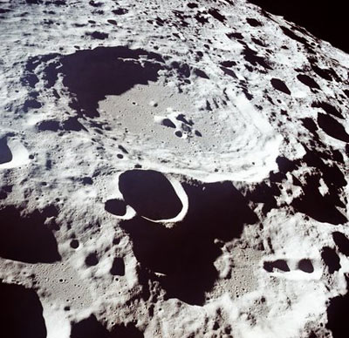

- OBTAINING THE BINARY IMAGE OF THE GIVEN INPUT IMAGE:

Thresholding is the simplest method of image segmentation. From a grayscale image, thresholding can be used to create binary images
During the thresholding process, individual pixels in an image are marked as “object” pixels if their value is greater than some threshold value (assuming an object to be brighter than the background) and as “background” pixels otherwise. This convention is known as threshold above. Variants include threshold below, which is opposite of threshold above; threshold inside, where a pixel is labeled "object" if its value is between two thresholds; and threshold outside, which is the opposite of threshold inside. Typically, an object pixel is given a value of “1” while a background pixel is given a value of “0.” Finally, a binary image is created by coloring each pixel white or black, depending on a pixel's labels.

FIXED VERSUS DYNAMIC THRESHOLDING:

- In fixed (or global) thresholding, the threshold value is held constant throughout the image:
g (x ,y) = 0 if f (x ,y)<T
g (x, y) = 1 if f (x ,y)>=T

- Local (or dynamic thresholding): depends on the position in the image. The image is divided into overlapping sections which are thresholded one by one.

The following iterative algorithm have been used to obtain the thresholded image of the given input image.

ALGORITHM:

1.Select an initial estimate for T (usually average intensity)

2. Segment the image using T. This produces 2 groups: G1 pixels with intensity value >T and G2 , with intensity values <=T

3. Compute the average intensity values μ1 and μ2, for the pixels in G1 and G2 respectively.

4. New threshold: T=1/2(μ1+μ2)

5. Repeat steps 2 to 4 until T stabilizes.

After applying the above algorithm, we get the output image which is given in the figure below.

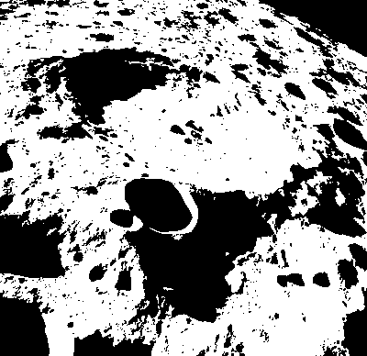

2>DETECTING THE EDGES IN THE BINRAY IMAGE:

A line may be viewed as an edge segment in which the intensity of the background on either side of the line is either much higher or much lower than the intensity of the line pixels. Detecting changes in intensity for the purpose of finding edge can be accomplished using 1st order or 2nd order derivative.

1st derivative in image processing are implemented using the magnitude of the gradient. For a function f(x,y), the gradient of f, at coordinates (x,y) is defined as the two dimensional column vector
grad (f)= 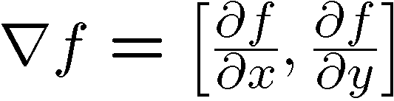

The magnitude of this vector, denoted as M(x,y), where
M(x,y) = √(g_{x2} + g_{y2})

Computing a derivatives in x and y direction using 3×3 neighborhood centered about a point consists simply of subtracting the pixels in the top row of the neighborhood from the pixels in the bottom row to obtain the partial derivative in the x direction. Similarly, we subtract the pixels in the left column from the pixels in the right column to obtain the partial derivatives in the y direction.
Let us assume this is a 3×3 neighborhood of the point (x,y).

z1 | z2 | z3
z4 | z5 | z6
z7 | z8 | z9

We discuss about three types of procedures for detecting edges. They are as follows:

(i)Robert Edge Detection: This procedure is based on implementing the diagonal differences.

g_{x}= (z₉ - z₅) and
g_{y}= (z₈ – z₆)

(ii)Prewitt Edge Detection: This technique use 3×3 mask that take account the nature of the data on opposite sides of the center point and thus carry more information regarding the direction of an edge. It uses the following equation:

g_{x} = (z₇+z₈+z₉)-(z₁+z₂+z₃) and
g_{y} = (z₃+z₆+z₉)-(z₁+z₄+z₇)

(iii)Sobel Edge Detection: A slight variation of the preceding two equations uses a weight of 2 in the center coefficient. i.e.

g_{x}= (z₇+2z₈+z₉)-(z₁+2z₂+z₃) and
g_{y}= (z₃+2z₆+z₉)-(z₁+2z₄+z₇)

In our project we have used Prewitt edge detection operator to find out the value of g_{x} and g_{y .} Then we calculate the magnitude value using the value of g_{x} and g_{y} to detect the edges.
And we have got the following output image as shown in the figure below.

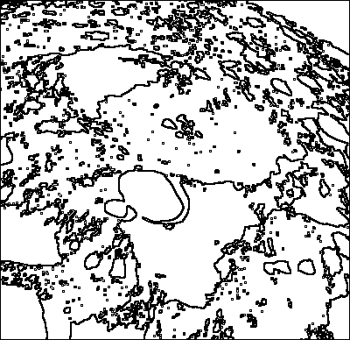

- THINNING:

Thinning technique is applied to thin the line segments. The thinning operation is typically applied repeatedly, leaving only pixel-wide linear representations of the image objects. The thinning operation halts when no more pixels can be removed from the image. It produces no change in the input image. At this point, the thinned image is identical to the input image.

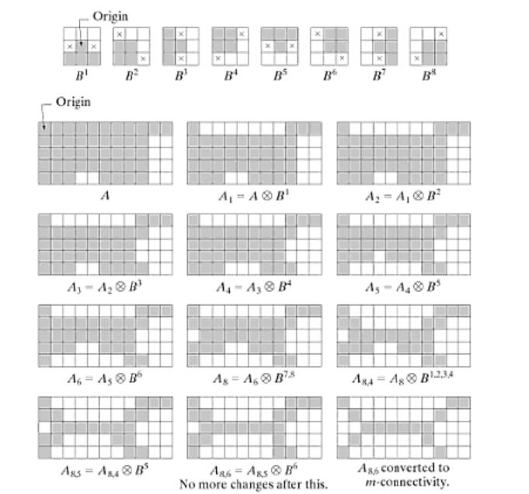

These are the 8 cases used in thinning and the results after using these. We also use this logic to make the detected edges thin in our project.
For example if the 1st case arise in an image i.e. the center pixel of a 3X3 neighbor and the lower row pixels are black, upper row pixels are white then there is no need to check the left and right side pixel, and we can make the center pixel white. Like this the other 7 cases are also implemented.

So we take each pixel and its 3X3 neighbor and check if it is satisfied with any of these 8 cases. Then we convert those pixels into white pixel.

After applying this algorithm we have got the output as follows:

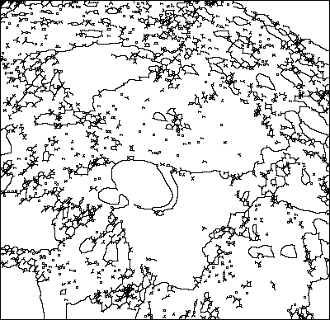

4>ELIMINATING REGIONS WHICH HAVE VERY FEW PIXEL COUNTS:

Region growing is a simple region-based image segmentation method. It is also classified as a pixel-based image segmentation method since it involves the selection of initial seed points.
This approach to segmentation examines neighboring pixels of initial “seed points” and determines whether the pixel neighbors should be added to the region. The process is iterated on, in the same manner as general data clustering algorithms. A general discussion of the region growing algorithm is described below.

It can be considered as a two step process wich is described below.
DIVIDING THE IMAGE INTO SEVERAL REGIONS:

1. An initial label value is chosen.
- An arbitrary white pixel is chosen.
- The predefined initial label value is assigned to that pixel.
- The 4-neighbour of that pixel is considered.
- If any of the 4-neighbour contains a black pixel the predefined label value is assigned to those pixel
- If any of the 4-neighbour contains a white pixel the label value is incremented, assigned to that pixel and step 4 and step 5 is repeated.
- The process is repeated until there are no more white pixels.

ELIMINATING REGIONS WHICH HAVE FEWER PIXEL COUNTS:

- From the result obtained using the above algorithm count the number of pixels with a given label.
- If this exceeds a predefined constant which in our case is 50 that region is considered to be an actual crater otherwise it is neglected.

After applying the above algorithm the output which we got is shown in the below figure.

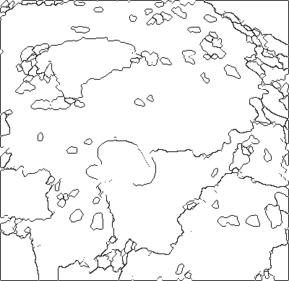

- OVERLAPPING THE RESULT:

After overlapping the before obtained result into the original image we have got the output as follows.

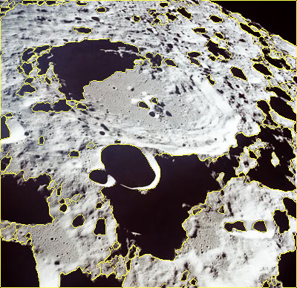

Results:

We have applied our algorithm to various moon surface satellite images. Some of them are shown here.

- The original image

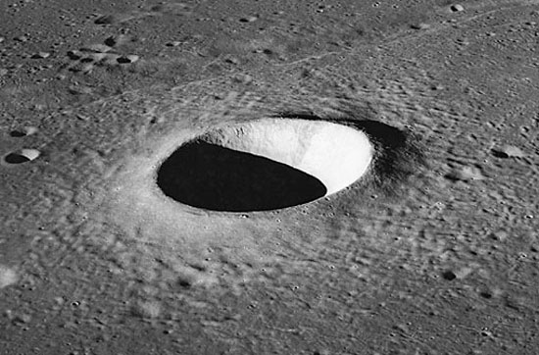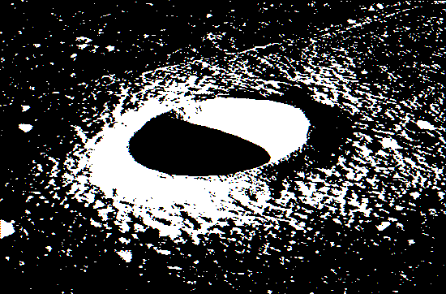

original image binary image

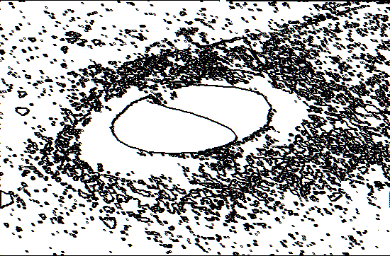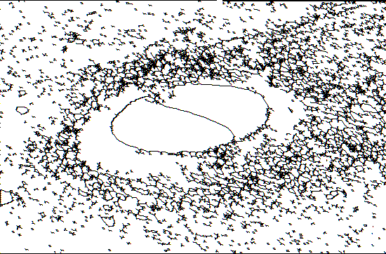

edge detected image image with thinned edges

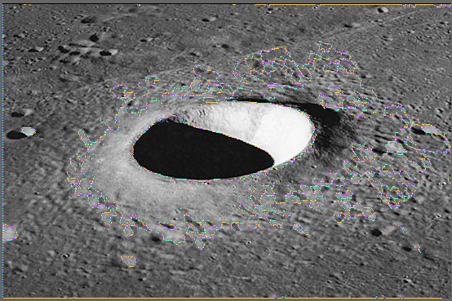
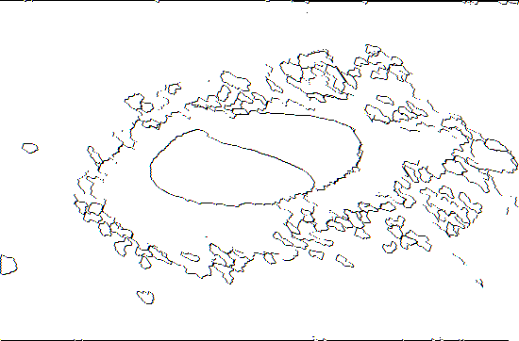

image after eliminating the small regions

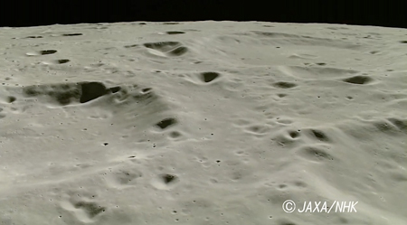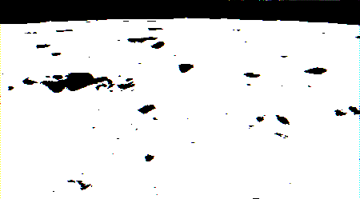
original image binary image

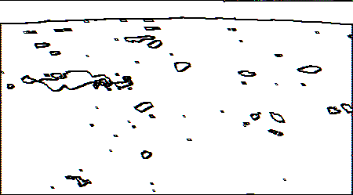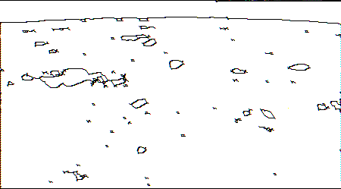
image after edge detection image with edges thinned

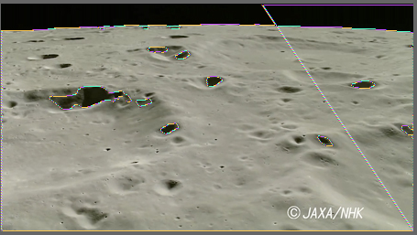
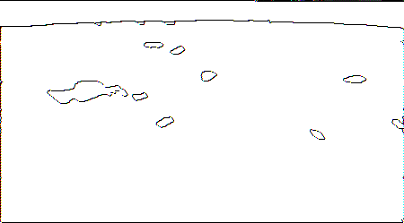

image after region grow and region elimination

Future Scope

In our project we have implemented the algorithm for .bmp files only. In future we will try to implement the algorithm for .jpeg images also. We will also try to implement other different segmentation mechanism in order to enhance the desired output. If required we will also modify our algorithm to get the desired result. If we observe the original images we can see that apart from the craters each image also contains shadow of the holes. In order to obtained efficient result we must detect the shadows and eliminate them. We have devised an algorithm that we hope will be able to detect the shadows and eliminate them. The algorithm is as follows.

DETECTING THE SHADOWS AND ELIMINATING THEM:
In order to do so, we 1st observe some images and notice that generally, the shadows are not circular in shape. In all those pictures light is fallen from left side. Thus horizontal length of the shadow is lesser than the vertical length. So we consider each region. If that region contains the intensity value within the range of 245 to 255, then find out the horizontal and vertical length of that region. If the horizontal length is greater than the vertical length, then we eliminate that region as it is a shadow. The similar logic can be applied if the light falls from other direction.

ALGORITHM:
This algorithm works on the output image obtained after the application of the previous region grow algorithm.

  - For each region consider only those regions whose average intensity is in the range of 245 and 255.( hence it is a black region )
  - Find out the left most pixel of that region.
  - For each black pixels which is in the 4-neighbor of the left most pixel calculate the Euclidean distance between each of the pair of black pixels.
  - Take the maximum of these distances and record it to be the highest vertical length of that region
  - Similarly find out the top most pixel of that region
  - For each black pixels which is in the 4-neighbour of the top most pixel calculate the Euclidean distance between each of the pair of black pixels.
  - Take the maximum of these distances and record it to be maximum horizontal length of that region.
  - If the vertical distance is less than the horizontal distance that region is not a shadow and hence a crater

Conclusion

This algorithm almost correctly identifies the craters in the image. However, the testing set is extremely small, and this algorithm should be tested on much larger number of examples (more than 100 examples) to get a better evaluation of its accuracy. By noticing the images we conclude the distinguishable feature of the shadows and craters. For any other images this conclusion may be wrong.

References

1. Digital Image processing- Rafel C.. Gonzalez, Richard E. Woods
2.http://gizmodo.com/5089936/nasa-scales-up-1966s-moon-image-to-amazing-ultra+high-resolution
3. http://www.nasa.gov/pdf/180572main_ETM.Impact.Craters.pdf
4. http://www.moonzoo.org/Lunar_Craters
5. http://hyperphysics.phy-astr.gsu.edu/hbase/solar/mooncrater.html
6.http://ieeexplore.ieee.org/Xplore/login.jsp?url=http%3A%2F%2Fieeexplore.ieee.org%2Fiel5%2F36%2F5447593%2F05404398.pdf%3Farnumber%3D5404398&authDecision=-203
7. http://en.wikipedia.org/wiki/RGB_color_model
8. http://en.wikipedia.org/wiki/Thresholding_(image_processing)
9.http://www.owlnet.rice.edu/~elec539/Projects97/morphjrks/moredge.html
10. http://homepages.inf.ed.ac.uk/rbf/HIPR2/open.htm

11. RESEARCH ON THE BUILDING SHADOW EXTRACTION AND ELIMINATION METHOD
GUO Hai-tao*, Zhang Yan, Lu Jun, Jin Guo-wang Zhengzhou Institute of Surveying and Mapping ,66 Mid-Longhai Road, Zhengzhou, China, 450052
-ht7776@163.com Commission Ⅲ, Ⅲ/5

